Heathkit Gotek Floppy Emulator Notes
26 January 2021

Table of Contents
Acknowledgements 1
Hardware 2
Software 2
Gotek 2
Hardware modification 2
Update the HXC 4
Flash the Device 5
Update the Device 6
Set the Device Config 6
Case updates 6
LCD Screen 6
3D Print Case 6
Connect to the H-89 7
Speaker 7
Using the HXC Floppy Emulator 8
File Formats 8
Tools 8
H8DUtility 8
Create Disk Image 8
Soft Sector 9
Hard Sector 9
Usage Notes 9
General 9
H8DUtility 9

Acknowledgements
Jeff at HxC for developing the firmware and software to modify the Gotek floppy emulator for Heathkit computer systems
Steven Hirsh, Mark Garlanger, Norberto Collado, Les Bird, and many others for providing the detailed technical knowledge of the Heathkit disk systems.

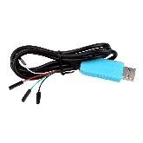
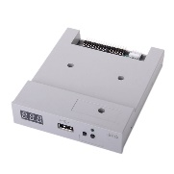
Hardware
- Gotek Floppy emulator ($27.99 from Amazon)
- USB to TTL Serial Cable ($6.99 from Amazon)
- USB flash drive (32GB works, probably could use smaller)
- Floppy disk cable with twist

Software

Download the software from the following webpage
- USB STM32 HxC Floppy Emulator firmware for Gotek update: HXCFEUSB_HFE_beta_firmware.zip
- Last firmware release notes : USB_HFE_hxc_floppy_emulator_firmware_release_notes.txt
- Online Bootloader programmer: STM32_SerialBridge.zip
- You can purchase the firmware on this page : http://hxc2001.com/store/

Gotek

Hardware modification
Your drive may need to modified in order to program it. It needs a set of jumper pins added to connect the serial cable.
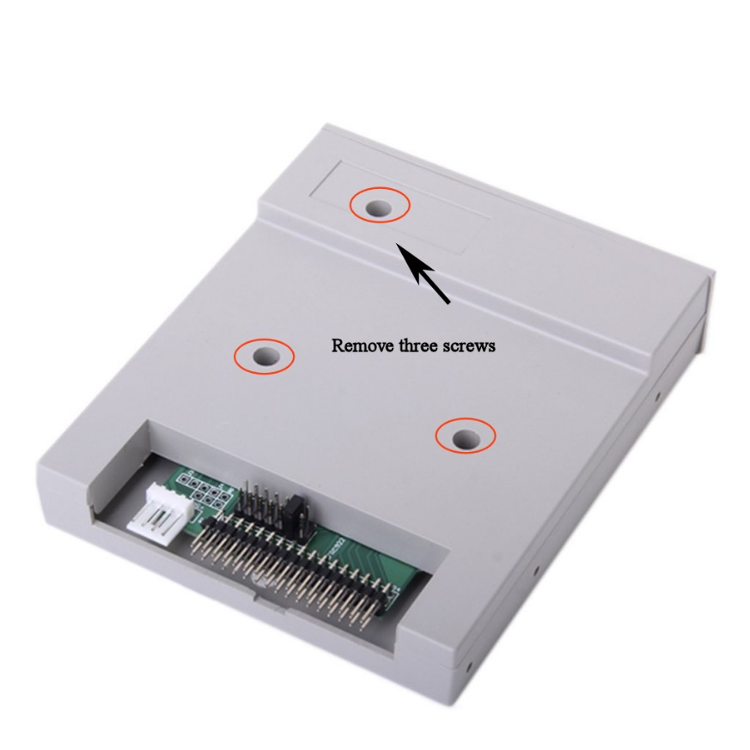

Solder a set of dual jumper pins in the area indicated.
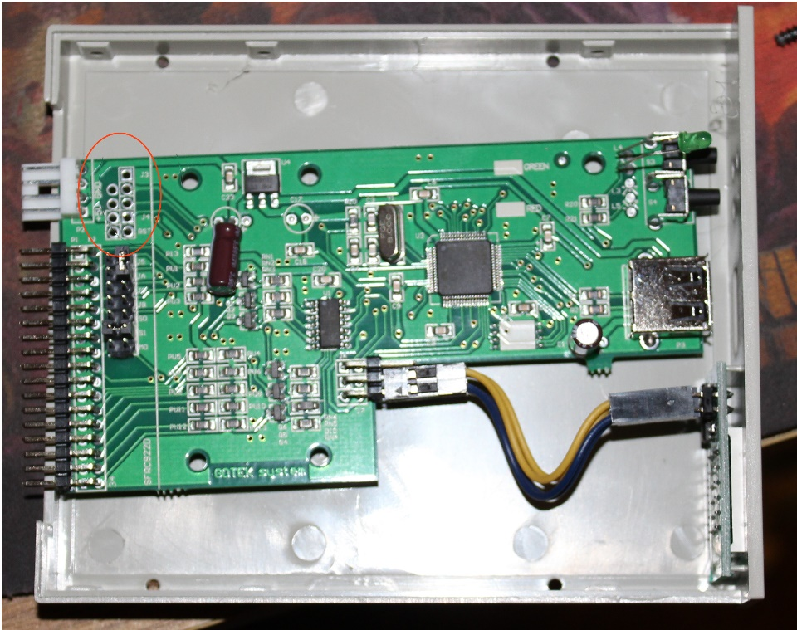

Reassemble the unit

Update the HXC

You should have purchased the software and downloaded the serial loader software, SecSerialBridge. The purchase email listed the server IP address and login information.
Connect the serial cable as indicated in the First time bootloader Flashing/Programming process at the following link. Note the jumper at J3. You may need to use a wire to briefly ground the Reset pin if the software doesn’t like up initially.
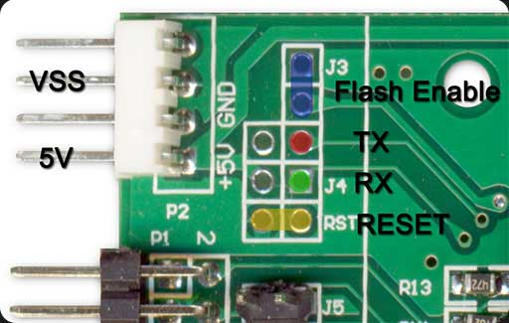
Serial cable pinout
Red cable: +5V
Black cable: GND
Green cable: TXD
White cable: RXD

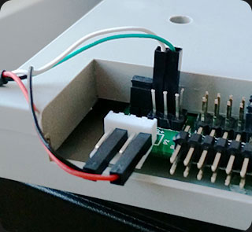
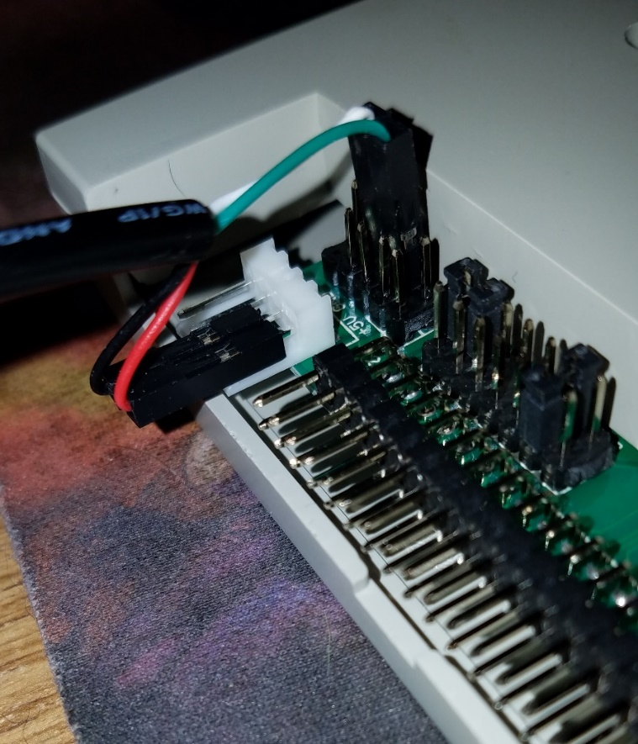

Flash the Device

Follow the directions to flash the unit with the new bootloader
- Start the SecSerialBridge software and select the COM port of your serial adapter. Click on the button "Open"
- Enter the server and your contacts data. Click on the button "Connect".
- If the connection to the server succeed you will get the "Link is UP !" status.
- Some seconds later you should get the "Device detected." status.
- Note : If you don't get it, try to reset the STM32 by making a short connection of the reset signal (RST) to GND.
- Once the device is detected, you can press the "Program" button.
- The download and programming process finish with a "Done !" Status. The whole process take some minutes.
- Once done, remove all the connections previously done on the programming pins.

- The device should now display "Ldr" at power up and wait for a USB flash drive with a UPD file to use.

Update the Device
- Copy the new firmware file (*.upd) to a FAT32/FAT16/FAT12 USB flash device.
- Insert the USB Stick into the emulator and press both buttons.
- Power up the device and keep both buttons pressed during at least 2 seconds.
- Wait some seconds... its done !

Set the Device Config
- Download file HXCFEUSB_HFE_beta_firmware from web page http://torlus.com/floppy/forum/viewtopic.php?f=33&t=1683. Direct link: http://hxc2001.com/download/floppy_drive_emulator/HXCFEUSB_HFE_beta_firmware.zip
- Select the config file for index mode

Case updates

LCD Screen
- Purchase LCD screen from ebay
  - 0.91" 128x32 I2C IIC Serial Blue OLED LCD LED Display Module 12832 SSD1306
  - New Blue IIC I2C TWI 1602 16x2 Serial LCD Module Display for Arduino
- You can connect the screen directly to the J7 connector. (additional pull-up resistors NOT required.)
- Use Normal mode

3D Print Case
- 5.25” https://www.thingiverse.com/thing:3433333
- 3.5” https://www.thingiverse.com/thing:3433312
- The picture shows both the 5.25” case on top and a 3.5” case in the original drive bay. Both designs support a additional button for selecting the file to use. The 5.25 case supports both the larger LCD display and the
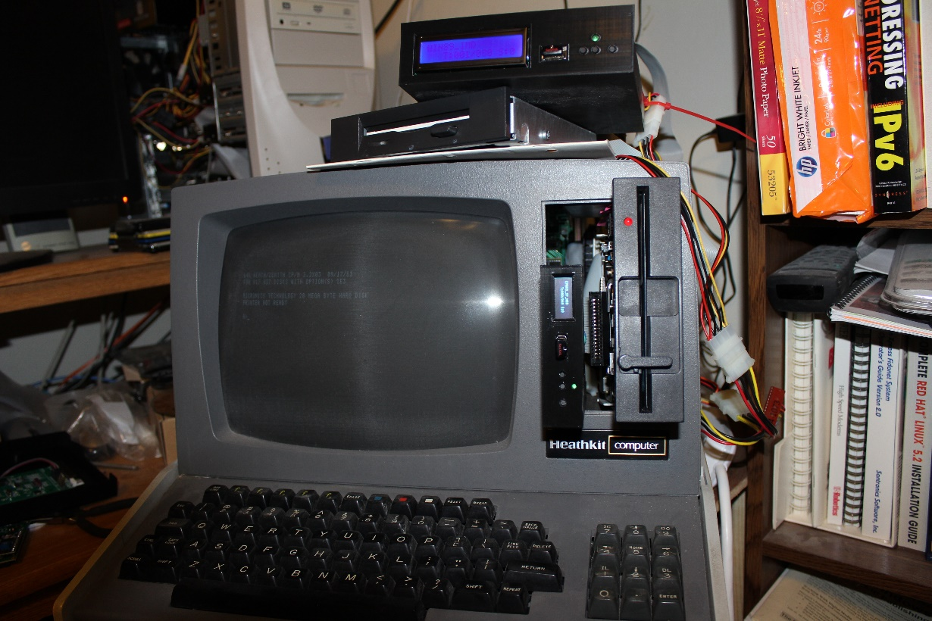
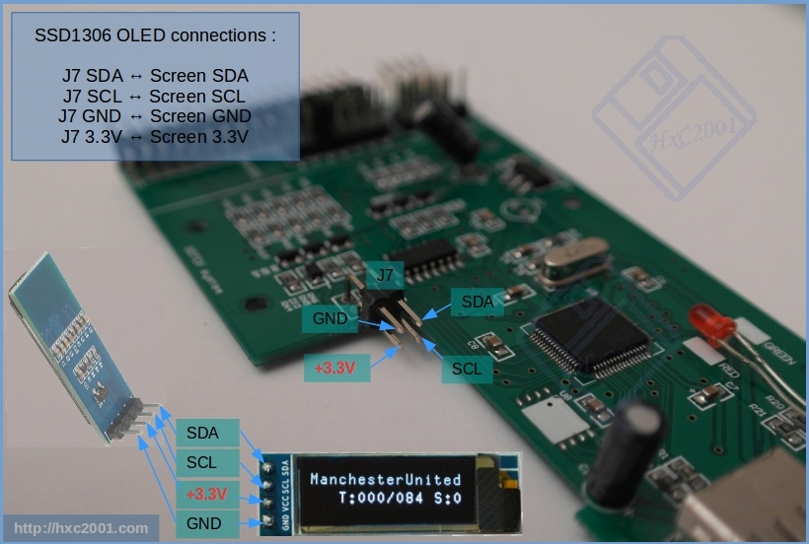

Connect to the H-89
- H-17 Hard Sector controller
  - The Gotek should be connected after the twist for drive 0
- H-37 soft sector controller
  - The Gotek can be connected using a standard PC twisted cable using either connection

Speaker
- Add a speaker to hear track changes

Using the HXC Floppy Emulator

File Formats
- HFE – used by the HXC Floppy Emulator. HFE is a bit map of the MFM data on the floppy disk
- IMD – Disk image format created by Dave Dunfield. It is an sector image of a floppy disk that uses a compression for sectors with identical bytes e.g. E5
- H8D – Standard Heath hard sector format
- H37 – sector image of a soft sector disk. Supports 40 and 80 track images.

Tools
- HXC Floppy Emulator software
- IMD by Dave Dunfield. Used to extract disk images from original floppies
- H8D Utility version 2.2 written by Les Bird and modified by Darrell Pelan to add H37 and CP/M file support

H8DUtility
- Use the H8D Utility to manage your files.
  - List the files in IMD, H8D, and H37 images.
  - Add files to H37 CP/M and H8D images.
  - Extract file from H8D, H37, and IMD formats to your Windows system
  - Convert H37 to IMD file format
- You need to convert H37 images to IMD in order to use the HXC Floppy Emulator software to create a HFE file to use int the HXC Floppy Emulator.

Create Disk Image
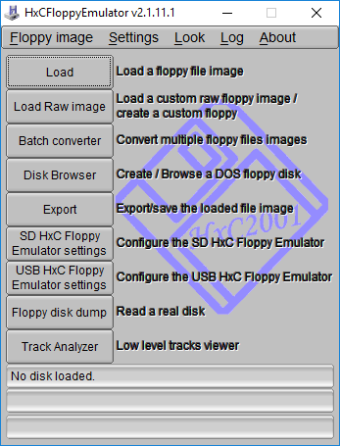
- Open the HXC Floppy Emulator software

Soft Sector
- Click Load and navigate to the directory with .IMD file you wish to load.
- Click Export and select "HFE" as the export file type for soft sector controllers
- Copy the exported file to the USB flash drive. You will also need the latest Beta firmware from the HXC site the first time you load the Gotek.

Hard Sector
- Click Load and navigate to the directory with .H8D file you wish to load.
- Click Export and select "HFE version 3" as the export file type for hard sector controllers
- Copy the exported file to the USB flash drive. You will also need the latest Beta firmware from the HXC site the first time you load the Gotek.
Note: The hard sector format is read only. The HxC software does not support writing to the disk

Usage Notes

General
Once you flash the Gotek with the HxC software, it’s operation changes. I used Dave Dunfield’s IMD software to read my floppy disks from the 80’s on my Windows 95 system, hardware circa 1995, to read the disks into a IMD format. The HxC Floppy Emulator software converts an IMD image to HFE. The flashed Gotek uses the HFE format on the flash drive. Data can be read and written to this format for soft sector images. HFE is a bit map of the MFM data on the floppy disk.
The USB drive is formatted in DOS FAT32. Each floppy disk image is a separate file. Each file needs to be in the expected format for the target system. The LCD screen is nice because it shows the DOS file name so you know which “disk” you are using.

H8DUtility
You can use HxC Floppy Emulator to convert the HFE file back to an IMD image. The IMD file format uses a storage method where sectors with single byte value are stored with an identifier, byte count, and byte value. This method makes it hard for image reading software since the sectors are not the same size.
The H8DUtility can convert the IMD files to an H37 format. The H37 format is a byte for byte image of the disk.
The H8DUtility program can extract and add CP/M files, but not delete them. It can also create a blank image that you can add file to in order to transfer data. On a H-89, the first sector contains a byte that tells the operating system how big the disk is, including the number of tracks and sides. This allows you to have images of both 40 and 80 tracks.

